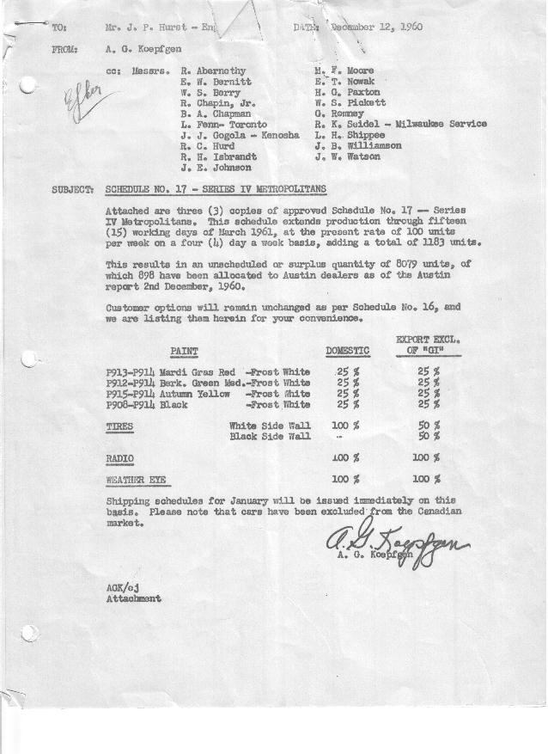

FORM AM 1262 APPROVED R. Abernethy (signed) DATE 12-16-60

SCHEDULE NO. ______17 ___ DATE 12-12-60 MONTHLY BUILDING SCHEDULE APPROVED E.W.Bernitt (signed) DATE_ 12-16-60 _
REVISION NO. _______ __ ____ DATE PRODUCT APPROVED R. W.Chapin Jr. (signed) DATE 12/16/60 _
SERIES IV 1500 c.c. ENGINE
METROPOLITAN SERIES CARS – AUSTIN MOTORS CO., LTD, ENGLAND
DESCRIPTION | BUILT  ◻ACT◻ EST  THRU | FIRM BUILDING SCHEDULE  (FABRICATED MATERIAL RELEASE) |  |  |  |  |  |  |  |  |  |  |  |  |  |  | TENTATIVE SCHEDULE  (RAW MATERIAL RELEASED) |  |  | GRAND  TOTAL
DESCRIPTION | BUILT  ◻ACT◻ EST  THRU | MONTH DECEMBER  DAYS 15 |  |  | MONTH JANUARY  DAYS 18 |  |  | MONTH FEBRUARY  DAYS 16 |  |  | MONTH MARCH  DAYS 15 (18 Available) |  |  |  |  |  |  |  |  | GRAND  TOTAL
DESCRIPTION | BUILT  ◻ACT◻ EST  THRU | DAILY | MONTH | CUM’L  TOTAL | DAILY | MONTH | CUM’L  TOTAL | DAILY | MONTH | CUM’L  TOTAL | DAILY | MONTH | CUM’L  TOTAL | UNSCHEDULED |  | CUM’L  TOTAL | DAILY | MONTH | CUM’L TOTAL | GRAND  TOTAL
DOMESTIC LHD:
Hard-Top | 24371 |  | 327 | 24698 |  | 394 | 25092 |  | 349 | 25441 |  | 327 | 25768 |  | 3878 | 29646
Soft-Top | 8418 |  | 33 | 8451 |  | 41 | 8492 |  | 36 | 8528 |  | 34 | 8562 |  | 2756 | 11318
Total U.S. | 32789 | 24.0 | 360 | 33149 | 24.2 | 435 | 33584 | 24.1 | 385 | 33969 | 24.0 | 361 | 34330 |  | 6634 | 40964
Over/(Under) Schedule 16 | (42) |  | -0- | (42) |  | 435 | 393 |  | 385 | 778 |  | 361 | 1139 |  |  | -0-
FOREIGN:
EXPORT LHD Hard-Top | 290 |  | 8 | 298 |  | 8 | 306 |  | 8 | 314 |  | 8 | 322 |  | 112 | 434
Soft-Top | 121 |  | 3 | 124 |  | 3 | 127 |  | 3 | 130 |  | 3 | 133 |  | 27 | 160
Total Export LHD | 411 |  | 11 | 422 |  | 11 | 433 |  | 11 | 444 |  | 11 | 455 |  | 139 | 594
RHD Hard Top | 63 |  | 3 | 66 |  | 3 | 69 |  | 3 | 72 |  | 3 | 75 |  | 40 | 115
Soft Top | 26 |  | 1 | 27 |  | 1 | 28 |  | 1 | 29 |  | 1 | 30 |  | 10 | 40
Total Export RHD | 89 |  | 4 | 93 |  | 4 | 97 |  | 4 | 101 |  | 4 | 105 |  | 50 | 155
Total Export LHD & RHD | 500 | 1.0 | 15 | 515 | .8 | 15 | 530 | .9 | 15 | 545 | 1.0 | 15 | 560 |  | 189 | 749
Over/(Under) Schedule 16 | 20 |  | -0- | 20 |  | 15 | 35 |  | 15 | 50 |  | 15 | 65
CANADA Hard-Top | 1691 |  | -0- | 1691 |  | -0- | 1691 |  | -0- | 1691 |  | -0- | 1691 |  | 996 | 2687
Soft-Top | 340 |  | -0- | 340 |  | -0- | 340 |  | -0- | 340 |  | -0- | 340 |  | 260 | 600
Total Canada | 2031 |  | -0- | 2031 |  | -0- | 2031 |  | -0- | 2031 |  | -0- | 2031 |  | 1256 | 3287
Over/(Under) Schedule 16 | (21) |  | -0- | (21) |  | -0- | (21) |  | -0- | (21) |  | -0- | (21) |  |  | -0-
Total Foreign | 2531 | 1.0 | 15 | 2546 | .8 | 15 | 2561 | .9 | 15 | 2576 | 1.0 | 15 | 2591 |  | 1445 | 4036
Over/(Under) Schedule 16 | (1) |  | -0- | (1) |  | 15 | 14 |  | 15 | 29 |  | 15 | 44 |  |  | -0-
GRAND TOTALS
Hard-Top | 26415 | 22.5 | 338 | 26753 | 22.5 | 405 | 27158 | 22.5 | 360 | 27518 | 22.5 | 338 | 27856 |  | 5026 | 32882
Soft-Top | 8905 | 2.5 | 37 | 8942 | 2.5 | 45 | 8987 | 2.5 | 40 | 9027 | 2.5 | 38 | 9065 |  | 3053 | 12118
Total | 35320 | 25.0 | 375 | 35695 | 25.0 | 450 | 36145 | 25.0 | 400 | 36545 | 25.0 | 376 | 36921 |  | *8079 | 45000
Over/(Under) Schedule 16 | (43) |  | -0- | (43) |  | 450 | 407 |  | 400 | 807 |  | 376 | 1183 |  |  | -0-
As of Austin’s Report 2nd December, 1960, this figure
Includes 898 units allocated to Austin Dealers

